**Automated PCB Component Identification Project**

Motivation –

* As the size of components mounted on printed circuit boards (PCBs) decreases, **defect detection** becomes more important.
* **Identifying components** of a given device in hardware reverse engineering, which is a **time-consuming and focused work** as there are several components in one device.
* **Hardware cannot be reconfigured** like software once deployed, so we must fully understand the product’s lifecycle.
* With the help of **AI/ML techniques**, we will try to solve this problem in the coming days.

Methodology –

* PST has many products with a diverse set of components whose **images serve as the inputs** into the system.
* First step - using **Optical Character Recognition (OCR)** to extract relevant details about components (and the PCB itself), **details such as product, lot and/or revision numbers**.

Milestones –

* **Identifying components from Images** - Identifying hardware components, especially components that include digital logic
  + <https://aws.amazon.com/what-is/ocr/#:~:text=Optical%20Character%20Recognition%20(OCR)%20is,words%20in%20the%20image%20file>. (About OCR )
  + [GitHub - JaidedAI/EasyOCR: Ready-to-use OCR with 80+ supported languages and all popular writing scripts including Latin, Chinese, Arabic, Devanagari, Cyrillic and etc.](https://github.com/JaidedAI/EasyOCR) ( OCR libraries )
  + [GitHub - JaidedAI/EasyOCR: Ready-to-use OCR with 80+ supported languages and all popular writing scripts including Latin, Chinese, Arabic, Devanagari, Cyrillic and etc.](https://github.com/JaidedAI/EasyOCR) ( EasyOCR)
  + [GitHub - PaddlePaddle/PaddleOCR: Awesome multilingual OCR toolkits based on PaddlePaddle (practical ultra lightweight OCR system, support 80+ languages recognition, provide data annotation and synthesis tools, support training and deployment among server, mobile, embedded and IoT devices)](https://github.com/PaddlePaddle/PaddleOCR) ( PaddleOCR)
* **PCB and Component Identification -** Identify these components and list them in the CycloneDX (<https://github.com/CycloneDX/cyclonedx-property-taxonomy/blob/main/cdx/device.md>) style of Hardware Bill of Materials (HBOM).
  + After text extraction, logo or emblem identification can also be used to help in characterizing components.
  + [bom-examples/bom.json at master · CycloneDX/bom-examples · GitHub](https://github.com/CycloneDX/bom-examples/blob/master/HBOM/PCIe-SATA-adapter-board/bom.json) (data string format)
* **Database for Component Identification -** Building database for future. Using reinforcement learning for summarizing text.
* **Datasheet Retriever** – Collecting more data regarding the chips from datasheets of components from internet.
* **Interactive HBOM analysis –** Here we aim for fully automation or implementing with tools for arming security.

Questions –

* Data in each component may be in different font, size and color. So, we must be able to detect and analyze all such data with OCR techniques.

We are trying to implement OCR with few libraries like ‘EasyOCR’, ‘PaddleOCR’, OpenCV, tesseract.

* Can we use external tools or python libraries?

We should develop this project using python libraries but not with external web apps due to data integrity.

* What is CycloneDX?

CycloneDX is a design standard in which data regarding the component should be stored.

* what do we store in database?

We store all the data which we have mentioned about the component in CycloneDX format

* what additional data are we looking in datasheets for data in chips?

So, when we find a model number, there is a specific datasheet for every component. We are trying to store that whole data in database. There is no specification that it should be stored in structured format, we can store it as an unstructured data too as the style of collected data may vary from sites.

* Future work?

We are trying to make this whole process automated such that in a component if we try to click the data or a row, whole data related to that component should be displayed where this data would be stored in AWS.

Challenges –

* Data privacy: Many PCB manufacturers do not allow data collection due to confidentiality issue.
* Unique problems with the data: Because each PCB production plant uses has different types of PCBs and components used, data collected by one plant can not represent data from all production plants.

Step by step process –

This project can be done using Computer Vision and Machine Learning algorithms.

Taking pictures - > Identifying components in that picture (GUI (Qt Library) and algo’s in python and OpenCV) -> Image preprocessing (Using morphological operations) -> Extracting data from components (OCR libraries in python)

* Object detection consists of pre-processing, filtering and creation of bounding boxes for detected components.
* First, image is pre-processed using morphological operations. Erosion is used to flatten continuous areas and for removing noise.
* Image is divided into 3*3 size (Kernel) that consists of 0’s and 1’s.
* 1’s – minimum (erosion), 0’s – maximum (dilation)
* Thresholding is performed by computing a function for each pixel.
* Math….
* The watershed algorithm is used in order to determine the continuous areas of the chip packages.
* The watershed algorithm for image segmentation that accumulates in minima and is held back by maxima. A set of bounding points defines the established regions which we then approximate into rectangles.
* An alternative, semi-automated way of identifying components we implemented is brute-force template matching.
* First, a known component is manually marked on a first PCB or returned by the image segmentation. After that, the marked region is used as a template to detect other instances of the same component on a second PCB.
* The resulting bounding boxes are forwarded to the OCR module to determine the part numbers.

Image pre-processing: - We are using morphological technique for pre-processing.

Morphology is a method for image processing based on shapes. Once the segmentation is finished, morphological operations are used to remove the imperfections from the segmented image.

Here mainly we use Erosion, as binary images contain only 2 pixels, i.e., 0 and 255, It primarily involves eroding the outer surface of the image. The thickness of erosion depends on the kernel size.

Erosion- shrinks image pixels.

Dilation- Expands image pixels.

How do we implement Erosion: -

* Importing necessary packages
* Reading the image
* Binarizing the image
* It is advised to keep the foreground white, so we are binarizing the image using OpenCV’s invert operation.
* Now we use OpenCV’s erode() function to erode the boundaries of the image.

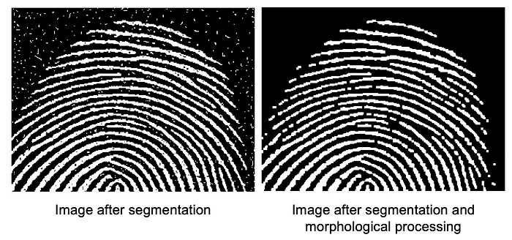

Watershed algorithm: -

* This algorithm is mainly used for extracting overlapping objects in images.
* We may not be able to extract each individual component from image using traditional image processing methods such as thresholding and contour detection, so here we are using Watershed algorithm to extract each component.
* First, we will do simple thresholding and contour detection
* Then we convert it to grayscale and apply Otsu’s thresholding to segment the background from the foreground.
* Lastly, we detect contours in the threshold image and draw each individual contour.
* Later we do segmentation using functions from scikit and OpenCV.
* Last step is to simple loop over the unique label values and extract each of the unique objects.

**Automated PCB Reverse Engineering**

Examining the printed circuit board (PCB) of the device is the initial step in examining the security of an embedded device without knowledge of the device's design. This is called PCB reverse engineering.

**Introduction -**

To assess the security of a device, is to analyze to hardware implementation. Without having access to proprietary specifications about the device under test, a penetration test is called black-box test. For embedded devices, black-box tests are common since most devices use proprietary PCB-designs and there is almost no re-use of designs across multiple PCBs of different products and manufacturers.

The main task in our project is to identify the PCB components, analyzing and storing them. After studying different approaches, found that Image Segmentation is the best alternative. Because PCB can contain multiple electronic components placed near each other, while Image segmentation can separate these by assigning each pixel to specific component. This makes component identification easy. Other advantage of using Image Segmentation is that it helps in feature extraction in features like shape and size. Also, PCB’s may contain complex backgrounds such as traces, solder joints or other components. Image Segmentation algorithms can separate the foreground and background, enhancing the accuracy and reliability of the identification process.

Moreover, our project is not fully automated, it still requires some manual help. But let’s try to minimize the manual effort.

**Related Work -**

In previous work on automated PCB reverse engineering, there are two ways: – destructive and non-destructive. In destructive method, device will destroy during the procedure and in non-destructive process, it retains full functionality of the device under test after analysis.

The goal of these methods is to fully reverse engineer a device, by extracting images of all PCB layers.

Longbotham describe how a PCB can be reconstructed using X-ray imaging techniques. They regard multi-layered PCBs with connection traces stacked within the board. Therefore, by this method, all layers can be inspected, and traces can be reconstructed clearly. This approach generates a very detailed copy of all layers of a PCB; however, it requires removing all the components and access to an X-ray machine.

Johnson shows how traces on a PCB can be analyzed using machine vision. He presents a program that reconstructs traces from the image of a raw PCB. A raw PCB is a circuit board that is stripped off components and solder mask. In order to use this approach on arbitrary PCBs, the analyst needs to unsolder the components and scrape off the solder mask.

As already indicated, all presented methods work destructively, rendering the device unusable after the analysis.

**Proposed technique: -**

Instead of removing or destroying either few parts or complete PCB, here we are taking the pictures of a PCB using a microscope. This will take pictures of 17 layers, combine them and gives the output which has great quality.

**Workflow of Manual PCB Reverse Engineering: -**

Advanced methods of PCB analysis are costly and time-consuming. The manual steps of this workflow are:

1. Identification of components by visual inspection (finding and reading the part number)

2. Gathering of documents related to these components (e. g., datasheets and reference manuals)

3. Extracting information from these documents (e. g., pinout diagrams and pin-signal mappings)

4. Probing important signals, such as buses and debugging interfaces, by using a multimeter (e. g., to find out connectors, test points, etc.)

The results of the workflow are:

• A part list (bill of materials)

• Technical documentation for all components

• A schematic reconstruction (e. g., a graph displaying connections between critical components)

**Automated workflow: -**

The images are first segmented by detecting common visual properties of microchips. The segmentation yields areas of the chip packages.

These areas are then handed over to an Optical Character Recognition (OCR) library in order to extract the part number that is printed on the package of an integrated circuit (IC).

The OCR results are matched against a database of known part numbers and manufacturer naming patterns in order to reduce false positives. If a valid part-number has been determined, the Internet is searched for related technical documents.

Matching documents are downloaded, and basic data is extracted from them, such as the feature description, pinout diagrams and pin-signal tables. Because technical documents usually come in PDF format, it is helpful to convert them into XML in order to easily parse the document’s structure and relevant pages. Based on matching keywords and the number of pages, the software filters out unrelated documents such as marketing brochures.

After every critical component has been identified and technical documents have been analyzed, the analyst probes physical connections between components on the PCB using a multimeter and enters them into the software. For example, a serial connection between two components can be added to the knowledge about the PCB by selecting both components and denoting their connection using the graphical user interface. The connections are stored in the database and can be changed or annotated at any point in time. This is especially useful for generating a visual report of all findings and communicating the attacker’s point of view to other parties involved, such as customers or engineering teams.

**Proof of concept Implementation: -**

In the research paper, they used a camera and setup for taking pictures. But in our case, we are using microscope for that, which is why we don’t need that setup.

The software implements a graphical user interface and algorithms for component identification in Python and OpenCV. The graphical interface is using the Qt library.

The background does not interfere with the analysis if it is a bright, solid color.

The first step in implementation is Image Pre-processing. We are using morphological methods i.e., erosion which is used to flatten the image and for removing noise.

Morphological operations modify images by considering the relative ordering of pixels within a structuring element, also called kernel. A kernel usually is a small matrix, 3×3 in our case, that consists of ones and zeros. The ones in the kernel define a pixel-neighborhood and all pixels in that neighborhood are set to the minimum (in case of erosion) or the maximum (in case of dilation) of the neighboring pixels. In our case, the kernel is positioned and applied on all possible locations of the image.

After that, thresholding is applied, in order to remove areas of the image that do not show the visual characteristics of chip packages.

The watershed algorithm is used in order to determine the continuous areas of the chip packages.

An alternative, semi-automated way of identifying components we implemented is brute-force template matching.

**Optical Character Recognition (OCR): -**

OCR is used to get the data printed on the components. Usually, data is printed in white color on the top of black chip. The pre-processed image is input for the OCR and gives the data as an output. Few resources have used AWS or Microsoft’s Clous vision APIs, but we are looking for something local like Easy OCR / Paddle OCR. After we get the output, a white space is added after every word, because manufacturers may also print batch numbers and other data on the chip. We try all possible sentences by calculating the cartesian product of the words. Then we compare it with the trained dataset or manufacturer’s report if available.

To extract relevant component data about these ICs from found PDF-documents, multiple open-source tools are used. First, the document is converted to both plain-text and XML using pdfminer.

For image segmentation we used a color-based segmentation in our proof-of-concept. We compared this to grayscale-based segmentation approaches, which proved usable for most PCBs. However, using color-information greatly increased robustness on PCBs that have big copper-areas in light silkscreens which generate dark areas.

For detecting components using patterns from already classified components, our proof-of-concept uses the template-based matching approach. While highly accurate, it proved less feasible to use across multiple PCBs than the presented alternatives because details, like variations in package size, dust, or differences in ambient light, already decrease the detection-rate of new components significantly.

For extracting the part numbers of detected components different OCR-frameworks have been evaluated. Initially, Tesseract was chosen as an OCR program, but was quickly replaced by Microsoft’s Cloud Vision API because the latter proved to be more reliable in detecting the part numbers correctly.

**Another paper inputs: -**

For detecting PCB’s –

1. Methodology –

* Collecting PCB images
* Color, shape and texture features have been extracted from windowed region
* Feature selection

My understanding: -

Image -> color correction -> dividing into non-overlapping boxes -> feature extraction -> OCR

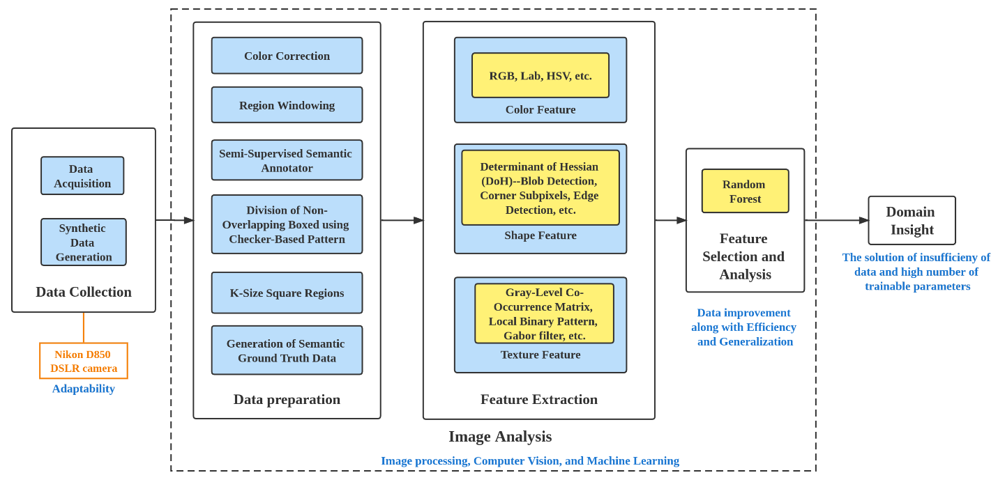

1. Data –

* Taking PCB images
* Performing color correction during preprocessing to normalize the data.
* Dividing each image into non-overlapping boxes in a checker-board pattern, the image data have been divided into square regions of different kernel sizes (ksizes) ---how?
* Performing feature extraction algorithm on each divided region for ksizes – 5,10,15,20,25
* As feature extraction have been performed on each of the non-overlapping box regions (bboxes) in the image, the ground truth needed to be in terms of the bboxes. Therefore, the bbox ground truth have been generated based on the semantic ground truth data, which consist of pixel-level labels of 1s and 0s for component and background, respectively. Each bbox ground truth region have been assigned values of 0–10 for the percentage of the region’s pixels that correspond to a component (e.g., a region with a value of 0 does not have any component pixels in the semantic ground truth, whereas a region with a value of 10 completely consist of component pixels in the semantic ground truth).

Questions -

After taking images, do we need color correction?

<https://www.planet.com/pulse/color-correction/> (color correction process using photoshop)

It depends on the background color and quality of an image.

The very first step in this project is to take the parts apart to get the PCB and take the pictures of components, but how? So here we have a microscope which can take amazing pictures with great quality.

Result after taking them apart-

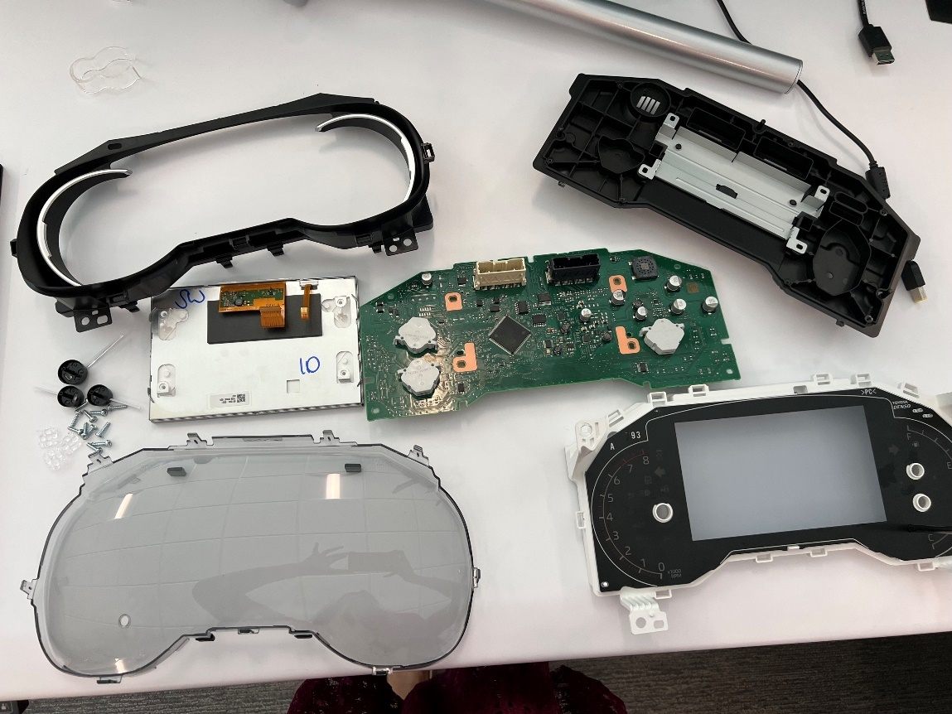

How to take pictures in the microscope?

Firstly, there should be enough space to store the picture. Now we need to adjust the PCB such that the horizontal and vertical sides are aligned straightly. And it is recommended to place the PCB on a stand for better quality. Now we adjust the corners of the PCB in Tile Scan, If the PCB is not in perfect square or rectangular shape then we can give more than two corners so that it will treat as a polygon and adjust that corner accordingly. Then in z-stack we give the top and bottom which is the highest point and lowest point on the PCB as this takes pictures from top -> bottom. We can ignore z-stack properties if we do not want to consider the data written on the top of components because z-stack may mess up the entire picture if we won’t define it properly. But as in our project the primary goal is to analyze the data from picture, we are considering it. Once the settings are done, it will go ahead and take pictures in 17 layers. It may take few hours to combine all the layers ang give and give the result.

Result of the PCB picture-

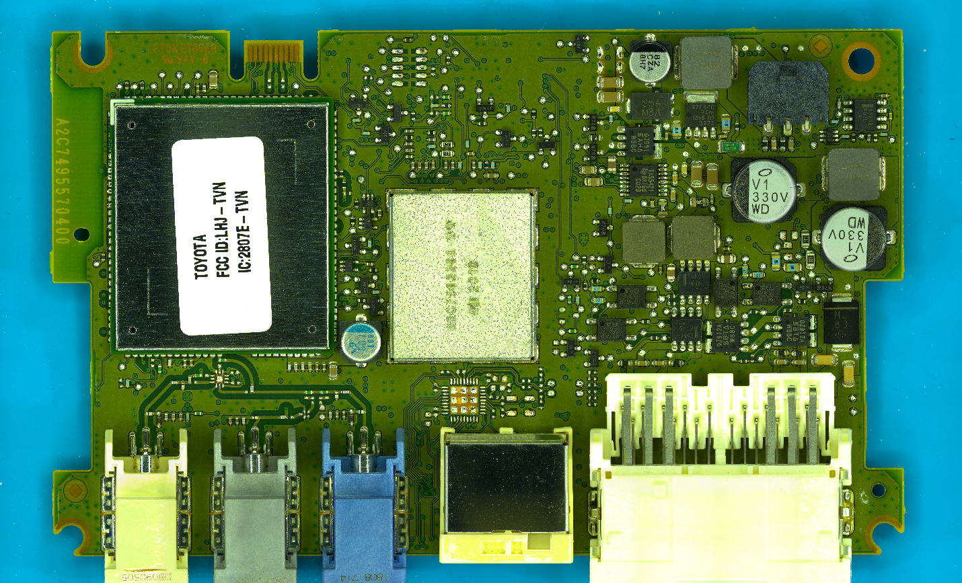

To start the process, I’m installing-

* Python
* jupyter notebook
* Anaconda
* VS Code
* PyCharm

**Approach – 1: - Using Morphological Methods - Erosion**

* As a first step, I’m trying **to pre-process** the image using morphological operations. Here I’m using **erosion** which is used to flatten the image.
* In this process, I have imported all the necessary packages, loaded and read my image.
* Binarized the image and defined a kernel of 3*3 matrix. This causes the edges of foreground objects thin; it works by eroding away pixels at the boundaries of objects in the image, causing them to shrink or become eroded.
* Inverted the image and eroded it.
* Finally, I tried to print the output

Challenges faced during implementation of Morphological methods –

* Faced an error while installing Package CV2, resolved by installing OpenCV.
* Faced an error while eroding image, that’s because image didn’t load properly. That could be either because of containing special characters in file name or the image you are trying to process didn’t load and was empty. Resolved it by loading the image properly.

Output –

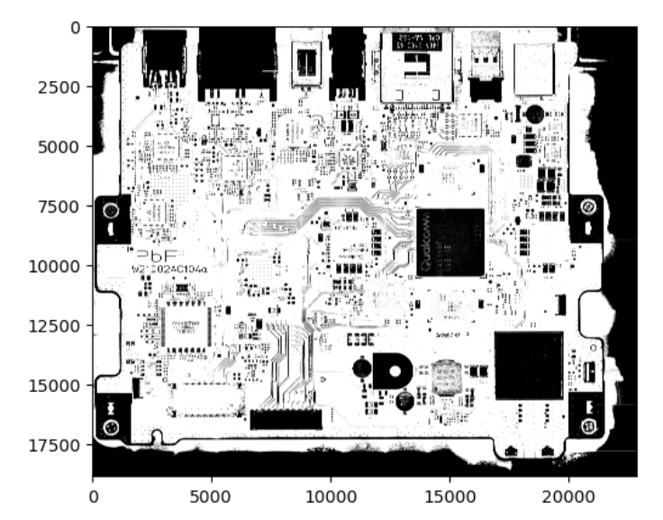

**Approach – 2: - Image Segmentation with Watershed Algorithm – OpenCV**

* Image Segmentation is a process of dividing an image into several disjoint small clusters according to specific rules.
* Watershed is a computer vision technique used for image region segmentation.
* During this process, it will take similarity of the adjacent pixels of the image for reference to connect pixels with similar gray values.
* Steps followed to implement Watershed Algorithm: -
  + - Importing the required libraries – cv2, NumPy, matplotlib, Image, display
    - Performing Preprocessing – here first it will encode the image to .jpg format if it’s not already in that format. Then it will convert from BGR to RGB as most of the libraries support RGB format. Now image is converted to grayscale using OpenCV’s “cvtColor” method. Converting to grayscale because it may reduce the dimensionality, removing color related information, edge detection and feature extraction would be a simpler process.
    - Tried HSV filtering but didn’t get good results compared to grayscale.

Output –

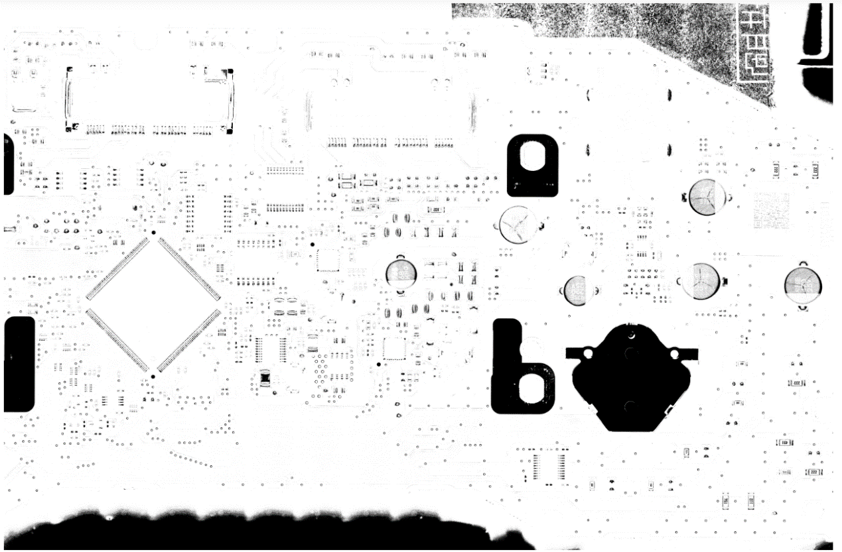

* + - Threshold Processing – Performing threshold on a grayscale image using Otsu’s thresholding method. It isa technique used in image processing to separate foreground and background of an image.
    - Noise Removal – Noise is removed by using morphological gradient processing, we get this by removing erosion from dilation.
    - This step includes four parts. We create subplots with 2 rows and 2 columns. First one is dilation, here we use dilate() function so that the borders in the image are increased which would be a sure background. We calculate and store the sure background area in ‘confident_bg’ variable. We display this image in [0,0] subplot titles under sure background.
    - Next step is distance transformation. Here we use distanceTransform() function which calculates the distance of every white pixel with the adjacent black pixel and value is stored in ‘distance’ variable. Image is displayed in plot [0,1] titled as ‘Distance transformation’.
    - Now we calculate the foreground area in the PCB by thresholding. And the image is displayed in plot [1,0] as ‘Confident Foreground’.
    - Then we are calculating the unknown area by subtracting background from foreground area which is stored in ‘not_sure’ variable and image is displayed in plot [1,1] titled as ‘Unknown’.
    - There is a gray area between the white area in this part of the background and the clearly visible white part of the foreground, which is uncharted territory, an undefined part. So, we will subtract this area.
    - The linked components of the sure foreground image "confident_fg" are first discovered using the OpenCV "connectedcomponents" method. "Mark" is used to store the outcome.
    - The values in "mark" are increased by one to make the distinction between the background and foreground.
    - The "not_sure" zone is represented by pixels with a value of 255, whereas the "mark" region is given the name "0."
    - Finally, the "mark" image is shown using the Matplotlib "imshow" function with the "tab20b" color map. The outcome is displayed as a 66 figure.
    - The "cv2.watershed" function is used to apply the Watershed algorithm to the original image "img" and the mark image acquired in the previous phase. "Mark" is used to store the outcome.
    - Utilizing Matplotlib's "imshow" method and the "tab20b" color map, the "mark" image is shown.
    - To extract the contours of each object, a loop iterates over the labels starting at 1 (ignoring the background and unlabeled regions).
    - Using OpenCV's "findContours" function, the contours of the binary picture are located, and the first contour is added to a list of coins.
    - Finally, "cv2.drawContours" is used to outline the items on the original image. The "imshow" function is used to display the outcome.

Output –

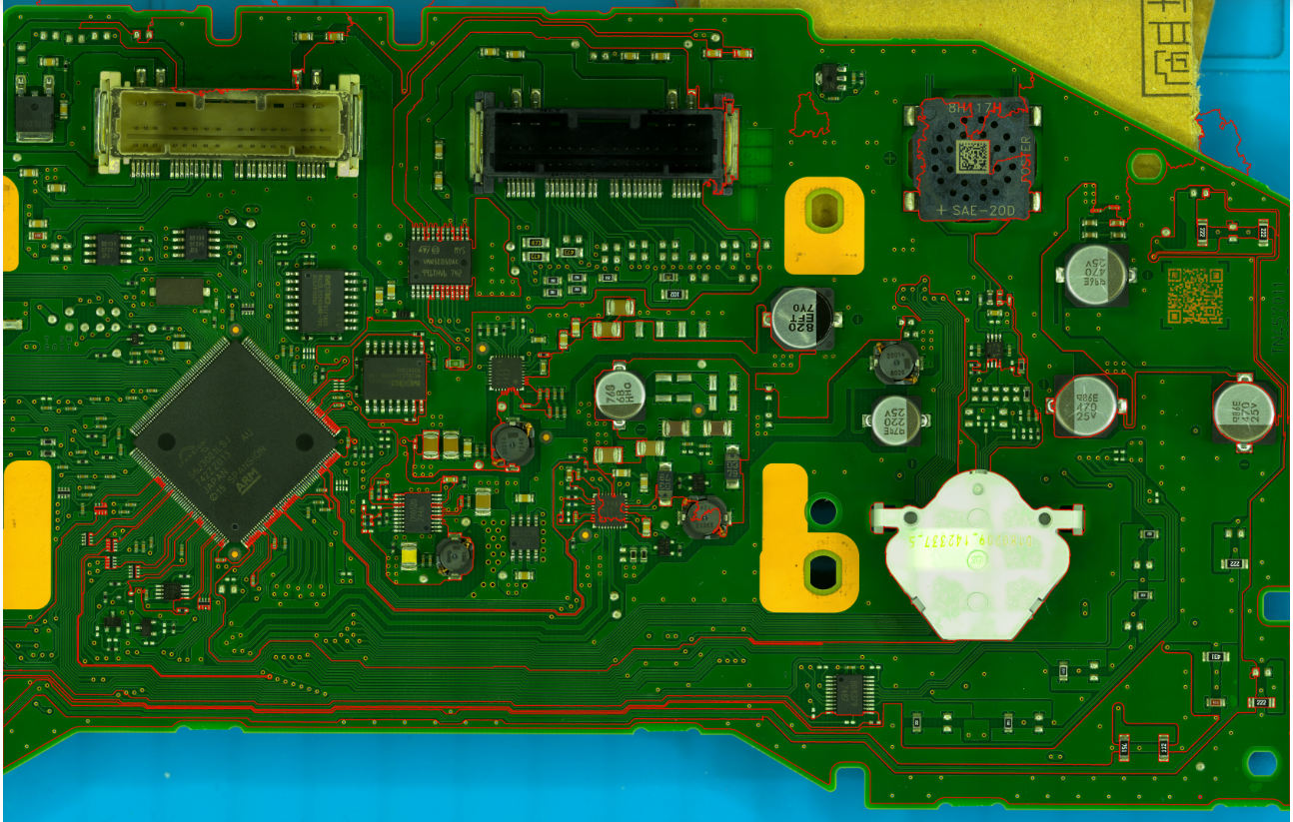

**Approach – 3: - Using YOLOv5 Object Detection**

YOLO – You Only Look Once, is an object detection framework using convolutional network. This approach is fast compared to others as it uses regression algorithm which reads the entire picture at once instead of reading every pixel one after the other and predicts the bounding boxes for the whole image at once.

Yolo breaks an image into a grid and then each section of grid is divided into objects and structures. Now it predicts where to place the bounding boxes using regression-based algorithms.

We require Yolov5 repository, Python 3.8 (later), PyTorch, CUDA for this approach implementation.

Downloaded YOLOv5 repository from github.

Installed latest version of Python.

Installed CUDA

Installed PyTorch

Working on google collab, downloaded the dataset from Roboflow, trained and tested it. We got the output, now we can detect the components but not with 100% accuracy. So, trying to train and test with different datasets which exist in Roboflow.

The output we got with ‘CompDetect’ datasets is –

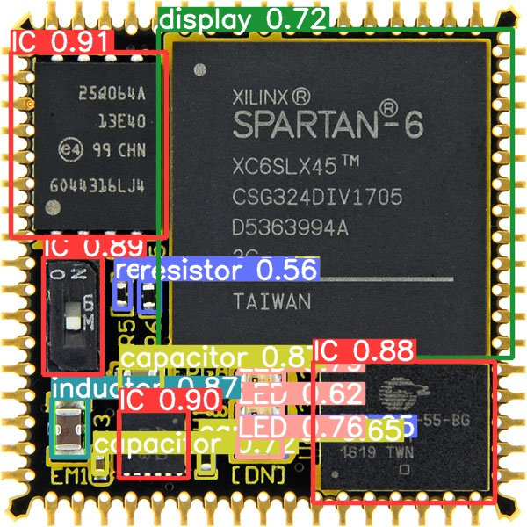

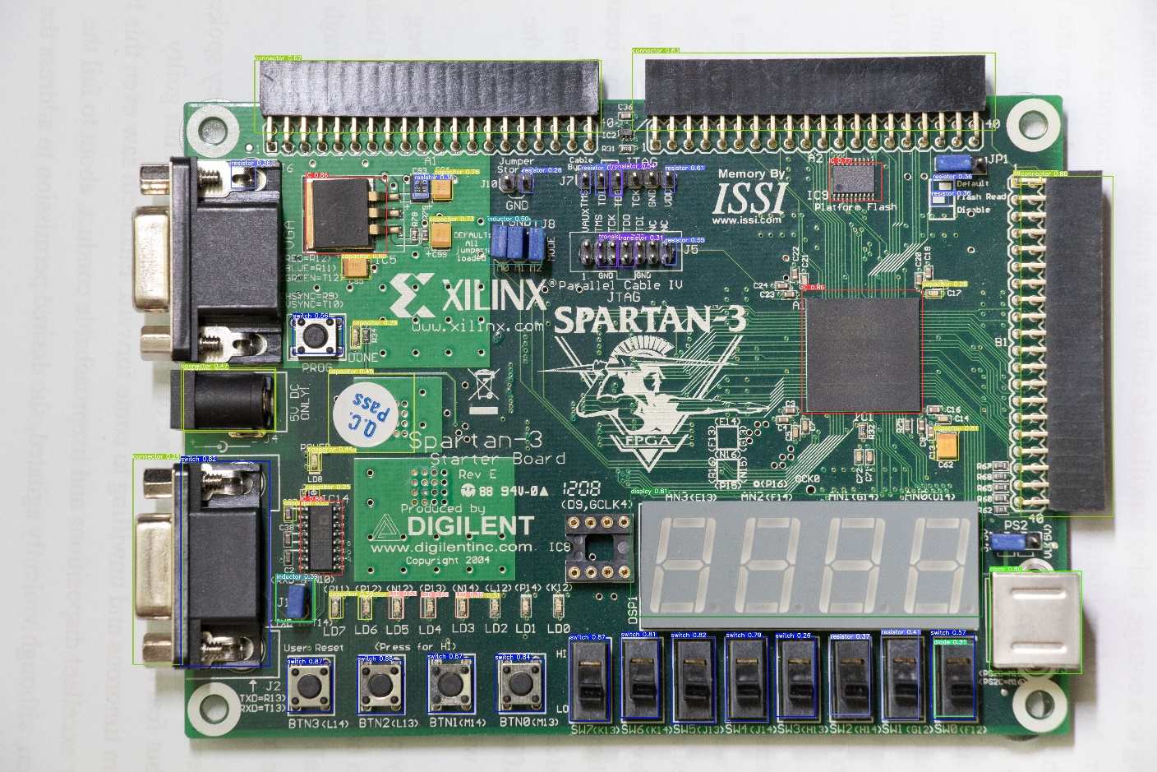

Tried with ‘PCB’ dataset -

Numbers represents types of components.

0 - Capacitor

1 - Resistor

2 - IC

3 – Diode

4 -

5 -

6 – LED

7 –

Works good with few boards, not identifying components in Toyota boards.

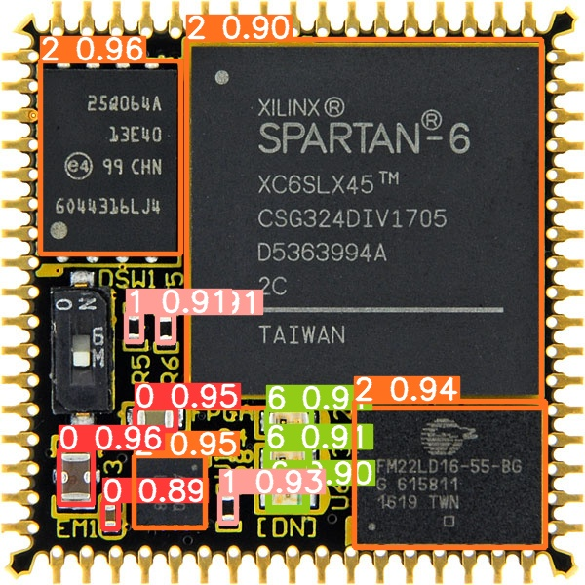

Identifying ICs in the board with ‘CompDetect’ dataset

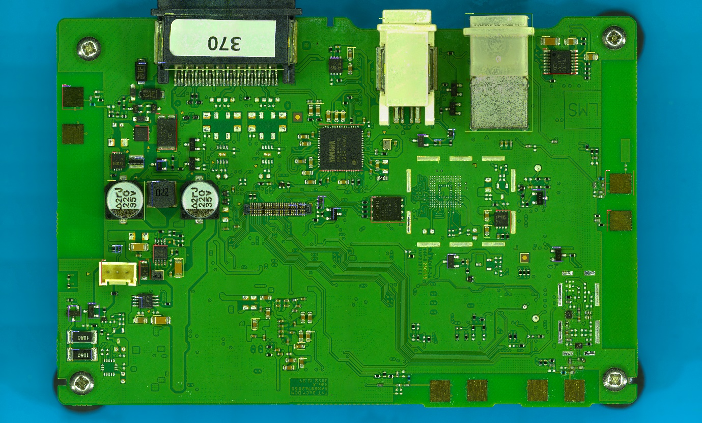

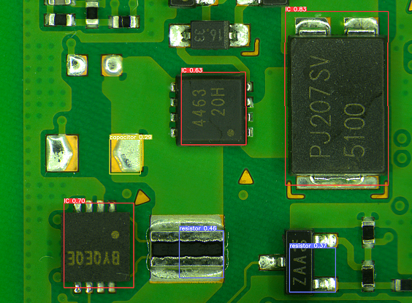

CompDetect dataset – img 640 batch 32 epochs 200 workers 4 – to compare accuracy between

100 epochs and 200 epochs.

If model failed to detect any components, we can get the coordinates of that component when we mouse click in the picture. So that we can chop it with the help of those coordinates.

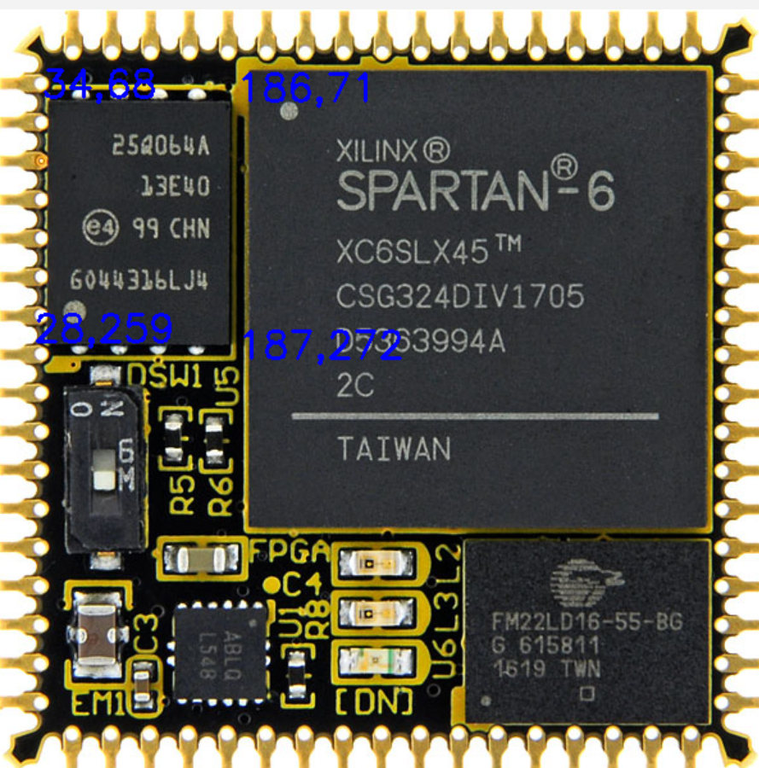

Trying with the dataset we created –

[PCB-Components - v1478 2023-07-11 10:23am (roboflow.com)](https://app.roboflow.com/nchowdarym/pcb-components-djhuq/1478)

As the images are with high resolution and are large size, we need high GPU RAM to process.

Training with img 640, batch 30, epochs 100 – failed to run.

Training with img 640, batch 20, epochs 100 – failed to run.

Training with img 640, batch 10, epochs 100 – failed to run.

Training with img 640, batch 8, epochs 100 – failed to run.

Training with img 640, batch 5, epochs 100 – but failed to run in validation.

Training with img 640, batch 4, epochs 100 – but failed to run in validation.

Training with img 640, batch 3, epochs 100 - but failed to run in validation.

Training with img 640, batch 2, epochs 100 - but failed to run in validation.

Training with img 640, batch 1, epochs 100 – but failed to run in validation.

* + - * Training with batch 1 is slow

Output without validation – not detecting all of the components

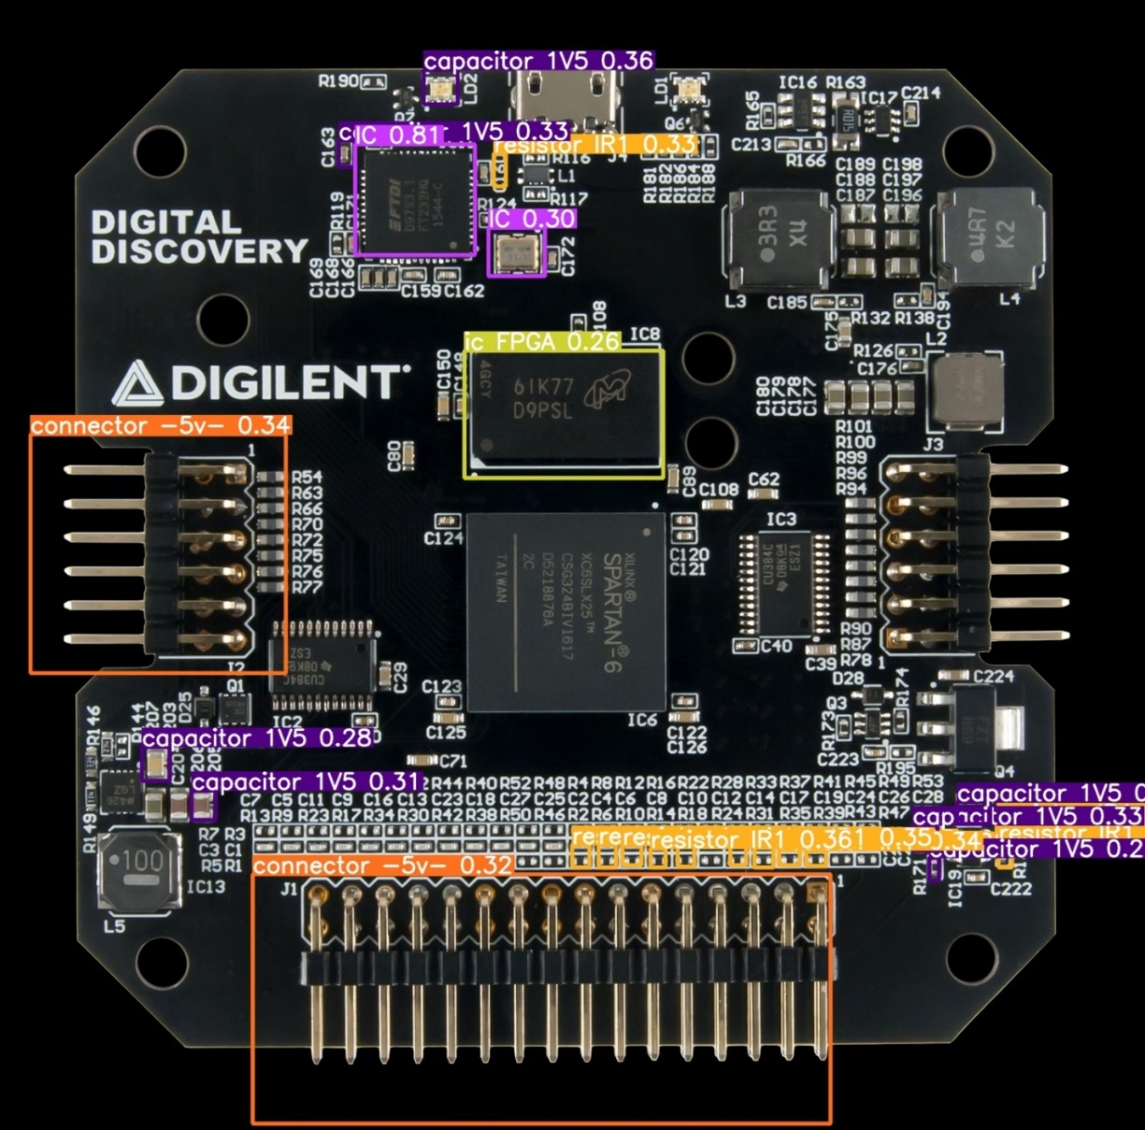

Should try with decreasing the workers in data loaders

Img 640 batch 16 epochs 100 workers 4 – trained but didn’t validate due to OOM error.

Img 640 batch 8 epochs 100 workers 2 – trained but didn’t validate due to OOM error.

Img 640 batch 4 epochs 100 workers 4 – trained but didn’t validate due to OOM error.

Img 640 batch 2 epochs 100 workers 2 – trained but didn’t validate due to OOM error.

**FINAL APPROACH: -**

Changed the approach as all the components are not getting detected with the available dataset, and detected components are not most accurate.

**Cropping Images: -**

Given input image (PCB), we must be able to drag the specific part of an image like snipping tool, then it should save automatically in two different folders.

One folder is for sending the images to OCR and the other is to create dataset for future.

Implementing this technique using ‘MouseEvents’, when the mouse button is clicked it tracks those coordinates till the mouse button is released. Now we can crop the selected part. We can change the color of the highlighted part with any color, here I chose white. Instead of cropping and selecting each chip, multiple images can be cropped and saved at once, I have used list for implementing this feature.

Sometimes, output is displayed very zoomed in, so I have set the screen size to a particular width and height which will be constant for all the images we run.

r – redraw the previous component in an image

c – clear everything

s – saving the cropped images

esc/q – close the window.

As all the images shouldn’t get saved with the same name, here I used uuid4() which generated a unique name every time. uuid4() is more secure than uuid1() and uuid3().

Now the cropped image is going to get saved in two different folders with unique names.

Once we get all the components images (here we are mainly focused on IC), we can send them to OCR.

**Extracting text from Images using OCR: -**

Optical Character Recognition is a process which converts and image to machine encoded text. Then it converts into text format.

Tesseract vs EasyOCR: -

* Tesseract works better with characters – EasyOCR performs well with words.
* Tesseract performs well with high-resolution, complex images, handwritten text - EasyOCR performs well for organized text like pdf files, receipt.
* Tesseract is preferable for CPU – EasyOCR is preferable for GPU machine.

As EasyOCR is lightweight module, it is not recognizing the characters of complex font. pyTesseract is giving good results with maximum accuracy.

Implementation: -

* Install pytesseract.
* Import necessary packages.
* Read the image.
* Setting path to the tesseract OCR engine executable.
* Performing OCR and getting the text from image.
* Defining language, engine and mode for better accuracy.

Here we define psm, where psm is page segmentation mode. When compared with all modes, mode 11 and 12 are giving good and accurate output.

11 – Sparse text. Find as much text as possible in no particular order.

12 – Sparse text with OSD.

When compared among 11 and 12, 11 is giving more accurate output while 12 is showing unexpected data which is not required.

If the chip has black background and the data is in bright color, then OCR can detect easily and gives accurate output, but as all the chips may not be in the same color, I have adjusted the brightness and contrast, so it is displaying the most accurate output.

If the image is rotated, we need to send it in right direction to OCR for getting the text, so we are using rotate() function.

I have implemented auto rotation by counting number of characters on each side, it will store and display the result of the side that has highest number of characters.

Now the output data is stored in .xml /.json format.

Here is the input image I have given to OCR after chopping.

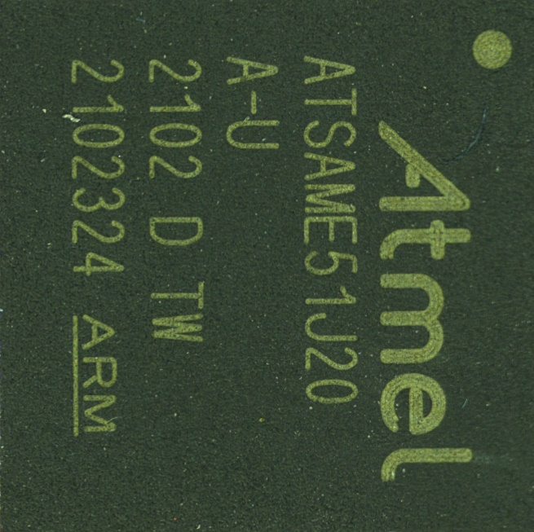

This image is automatically rotated and have given the following output.

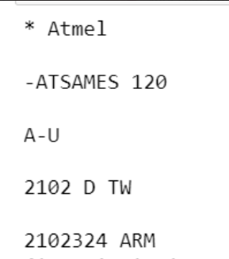

Now this data is saved in CycloneDX HBoM format.